YOUR FEEDBACK

ROUTE 96 NICHOLSON STREET TRAM STOP UPGRADES
Public Transport Victoria invited local residents and businesses from East Melbourne, Carlton, Fitzroy, Brunswick and Brunswick East to have their say on the proposed plans for upgrading six stops along Route 96 to level-access stops. Route 96 passengers were also invited to give their feedback on what is most important to them.
Two community drop-in sessions were held in May 2018 at the Melbourne Museum and Velo Cycles on Nicholson Street. Locals and passengers had a chance to discuss the planned upgrade with the project team, ask questions and provide feedback. Over 250 community members also provided their feedback through an online survey.

What is important to you
Community feedback was clear and strong about the importance of the project in providing:
- access for everyone with raised level tram stops
- better safety
- better passenger facilities
- smooth traffic flow.
The community is particularly understanding of the need to upgrade tram stops to improve accessibility and safety for all people.
Eight in ten survey respondents told us that they consider access to trams for mobility impaired passengers as the most important part of the upgrades.
“I am very excited for this upgrade, and the opportunity it will create for my friends and family in wheelchairs to get about Melbourne just like everyone else.”
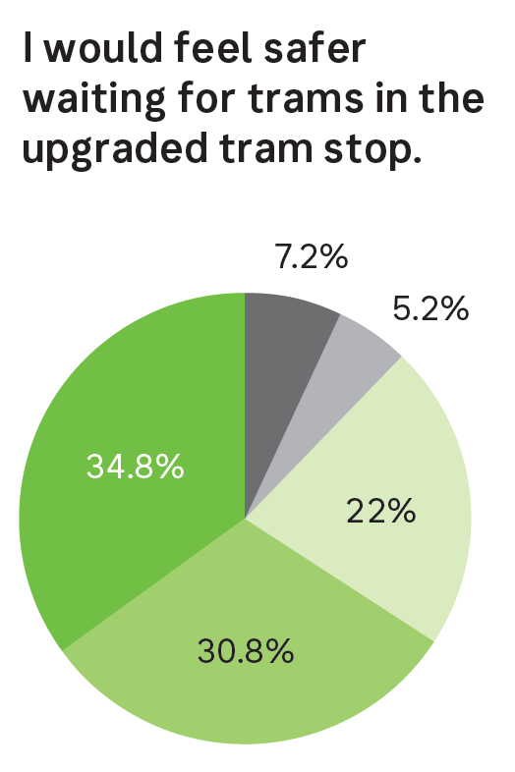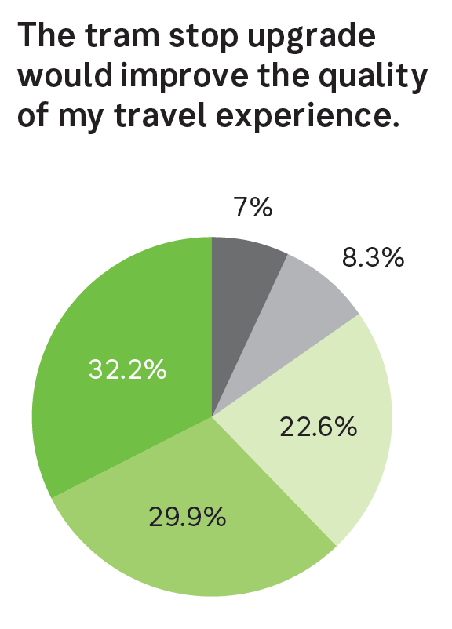
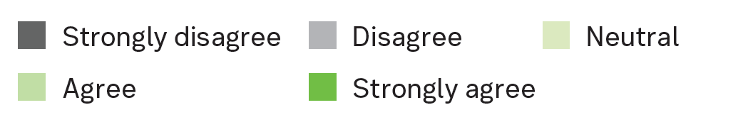

What you told us
The majority of survey respondents believe that the proposed upgrades will improve the safety and quality of their travel experience.
“I am looking forward to have these upgrades implemented soon. The current tram stop situation on Nicholson Street is unsafe for passengers boarding and disembarking the tram.”
“Desperately needed from a safety perspective. There have been so many near misses with traffic neglecting to stop and almost running passengers over. Bring it on!”
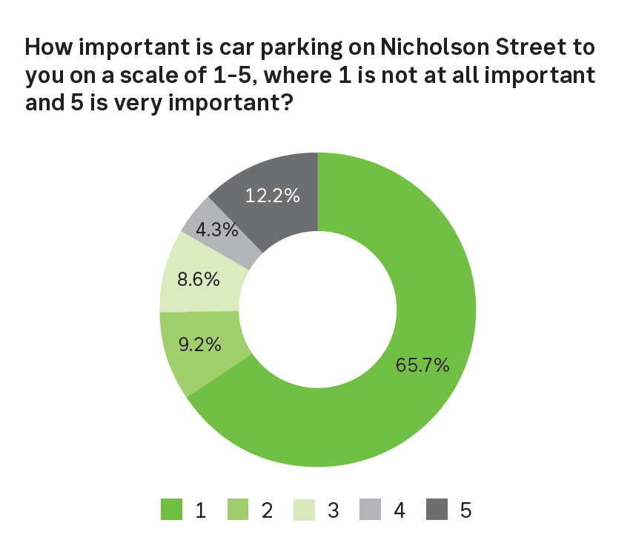
Feedback about traffic congestion and parking on Nicholson Street was raised again and again with the project team. Most feedback supported the priority of trams and cars moving down Nicholson Street, even at the expense of removing or restricting parking to provide more space for cars and trams.
Multiple community members told us that many existing tram stops were spaced too close together and welcomed the consideration of better spacing between stops.
“There are way too many tram stops, they are too close to each other.”
“It would be great if more stops were upgraded and to have some stops removed, e.g. the Victoria Street stop which is too close to the Blyth Street stop.”
While the community was glad to see the project progress, some locals also raised concern for the frequency of tram services on the Route 96.
“We need more trams, many times I couldn’t board at my stop because the tram was packed.”
“I would like to have more trams running more frequently during peak travel times, as often the trams are too full to board and are very squishy and uncomfortable to travel on, if you can manage to board at all.”
Multiple community members also enquired about when stops 16 to 22 along Nicholson Street are planned to be upgraded.
“Looking for communication on upgrades on other stops between Holden Street and Princes Street.”
“Please tell us what this means for the other stops – what is happening with Kaye Street and Alexandra Parade?”

Next steps
The Route 96 Nicholson Street tram stop upgrades are scheduled to be delivered for stops 11 to 15 and 23 to 26 in September 2018. The remaining tram stops 16 to 22 on Route 96 will be the next priority stops to receive an accessibility upgrade.
The project team will communicate and engage with local traders, businesses, residents and tram passengers prior to the start of the works to ensure that they are aware of the changes occurring along the tram route.
Thank you to everyone who shared their thoughts.

Keep informed
To keep informed about the Route 96 Nicholson Street tram stop upgrades project visit ptv.vic.gov.au/projects/tram-projects/route-96-upgrade or email mailto:ptvprojects@ptv.vic.gov.au

