Department of Transport
Sample Public Transport Plan Guide (All Modes)

The following document can be used as guide or template when
creating your Public Transport Plan (PTP), with the option to
insert your relevant event information and submit to
Department of Transport (DoT) for approval.

Sections of the Sample PTP may not be relevant to all
events within Victoria, due to their Metropolitan or
Regional locations.

In cases where events do not impact on a mode of
transport, this section can be removed from your
submitted plan.

Contents
Public Transport Plan 3
1. Event Description 4
2. Event Venue and Location 4
3. Summary of public transport service impacts 5
4. Summary of concurrent public transport service occupations 6
5. Summary of concurrent events in Melbourne/ Regional Victoria 6
6. Road Closure and Diversion Details 7
7. Changes to Traffic Conditions Details 7
8. Train Service Changes 8
9. Tram Service Changes 11
10. Working Around Train and Tram Overhead Wires 15
11. Bus & Coach Service Changes 16
12. Event Day Communications 19

Public Transport Plan

Event Name
Event Date
Event Logo/ Imagery

- Event Description
This includes the name, type and purpose of the event.
Event start time
Event finish time
Estimated event attendance

- Event Venue and Location
This may be an indoor or outdoor venue, local park, or on road event.
Address of venue.
An Aerial Map or SEMS Event Map can be inserted, indicating the affected roads and public transport routes surrounding the venue. These can be taken from Google Maps, Near Maps or SEMS.
For Example:

SEMS Location Map of Marvel Stadium, Docklands, including 300m surrounding impact zone
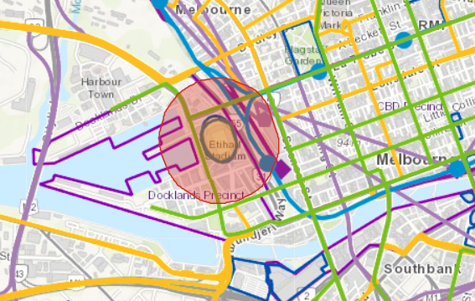

- Summary of public transport service impacts
Please complete this section either as you go, or at the end of organising your arrangements
Train Services
 | Level Crossing Impact | Additional Services | Replacement Services | Additional Staff/ Management | Additional Communications
Metropolitan (MTM) | Yes/No | Yes/No | Yes/No | Yes/No | Yes/No
Regional (VLine) | Yes/No | Yes/No | Yes/No | Yes/No | Yes/No
Other | Yes/No | Yes/No | Yes/No | Yes/No | Yes/No

Tram Services
 | Diverted Services | Additional Services | Replacement Services | Additional Staff/ Management | Additional Communications
Metropolitan | Yes/No | Yes/No | Yes/No | Yes/No | Yes/No
Regional | Yes/No | Yes/No | Yes/No | Yes/No | Yes/No
Other | Yes/No | Yes/No | Yes/No | Yes/No | Yes/No

Bus & Coach Services
 | Diverted Services | Additional Services | Replacement Services | Additional Staff/ Management | Additional Communications
Metropolitan | Yes/No | Yes/No | Yes/No | Yes/No | Yes/No
Regional | Yes/No | Yes/No | Yes/No | Yes/No | Yes/No
Coach | Yes/No | Yes/No | Yes/No | Yes/No | Yes/No

- Summary of concurrent public transport service occupations
Please complete this section either as you go, or at the end of organising your arrangements. This information will provide DoT and PTO’s with an insight into what external operations may impact on planning alternative transport arrangements. Advice can be received from the local PTO, Council or DoT.
Mode | Occupation/ s
Train (Metropolitan) | Sandringham Line Bus Replacement – Sandringham to Mordialloc - 21:00 Friday 14 to 03:00 Monday 17 August
Train (Regional) | Geelong Line Bus Replacement – Geelong to Southern Cross – All Day Saturday 15 & Sunday 16 August
Tram (Metropolitan) | Route 86 Bus Replacement – Waterfront City Docklands to Melbourne Museum – All Day Saturday 15 & Sunday 16 August
Tram (Regional) | N/A

- Summary of concurrent events in Melbourne/ Regional Victoria
Please list any other concurrent events that may impact on your event or occurring within the same Region. This information will provide DoT and PTO’s with an insight into what external operations may impact on planning alternative transport arrangements. Advice can be received from the local Council or DoT.
Date | Event Name | Event Location | Start time | Finish time | Estimated Attendance
Fri 14 Aug | AFL Geelong v Collingwood | MCG | 17:20 | 22:30 | 50,000
Sat 15 Aug | U2 concert | Etihad stadium | 20:00 | 23:00 | 45,000
Sun 16 Aug | Melton Community Festival | High Street | 12:00 | 17:00 | 20,000
*Concurrent event applies to those within the location/ region

- Road Closure and Diversion Details
Please indicate which transport mode will be affected by the below event road closures, including the nominated traffic diversion routes, as increased traffic congestion may affect public transport.

Train Tram Bus Coach
Road/ Street Name | Section | Direction closed | Date Closed | Time Closed | Diversion Route
St Kilda Road | Park Street to Flinders Street | Both Directions | Sun 16 August | 00:01 to 20:00 | Flinders St-Kings Way-Park Street
Linlithgow Avenue | St Kilda Road to Alexandra Avenue | Both Directions | Sun 16 August | 00:01 to 20:00 | Alexander Ave-City Rd-Sturt St-Kings Way-Park St

- Changes to Traffic Conditions Details
Will there be changes to speed limits set up and approved by the Roads team? List the roads and corresponding changes to speed restrictions. Information on changes to traffic conditions must be communicated to on road operators such as tram and bus operators.
Road | Section | Normal speed | Altered speed | Date | Time
Alexandra Avenue | Swan Street Bridge to City Road | 60 kmph | 40 kmph | Sun 16 Aug | 6:00 to 20:00
Swan Street Bridge | Alexandra Avenue to Batman Avenue | 60 kmph | 40 kmph | Sun 16 Aug | 6:00 to 20:00
In the instance where there is an existing Traffic Management Plan which includes this information, please indicate whether this document is attached to support this section of the plan

- Train Service Changes

Service Changes
Please indicate how Metropolitan or Regional train services will be impacted and managed as a result of the event, including the nominated bus replacement details, as increased congestion may affect the public transport network.
Please include details of instanced where events may cross over rail level crossings and require bus replacements, termination or additional management.
For example:

Sunday 16 August – Men’s Race at 11:10am

The following VLine Train services will be affected, due to the anticipated road closures prior to and following cyclists passing through Marshal Railway Level Crossing on Barwon Heads Road:

- 10:30am Melbourne to Waurn Ponds will terminate at Geelong, with a bus replacement between Geelong and Waurn Ponds.

- 11:16am Waurn Ponds to Melbourne will commence at Geelong, with a bus replacement between Waurn Ponds and Geelong.

Additional Train Services
Some large events may require additional train services. Additional train services are only provided under agreement with DoT, Metro Trains Melbourne and VLine. If your event has been acknowledged by DoT as requiring additional train services, please include the service details below as provided by Metro Trains and VLine:

Line | Station to Station |  | No. of Additional Services | Departure Time
Metro Trains
Alamein
Belgrave
Craigieburn
Cranbourne
Dandenong
Flemington
Frankston
Glen Waverley
Hurstbridge
Lilydale
Mernda
Pakenham
Ringwood
Sandringham
Showgrounds
South Morang
Stony Point
Upfield
Werribee
Williamstown
V/Line
Ballarat
Bendigo
Geelong
Seymour
Traralgon

Train Line and Railway Station Information
Please include details of the affected railway stations, which can be identified in SEMS using the Map and Information tools. Metropolitan Train Lines can be identified in SEMS by the Blue Lines, and Stations by the Blue Circles. Regional Train Lines can be identified in SEMS by the Purple Lines, and Stations by the Purple Squares.
Using the information tool provided, you can select a Line or Station to identify their description, and then List affected services etc.
Metropolitan Railway Line and Station Regional Railway Line and Station
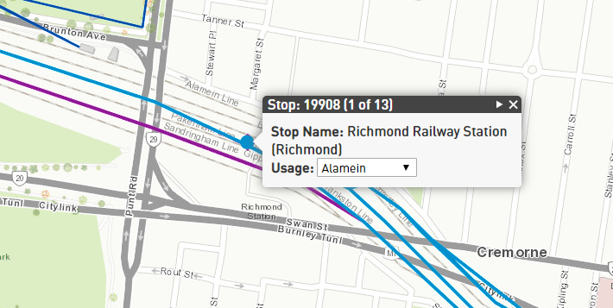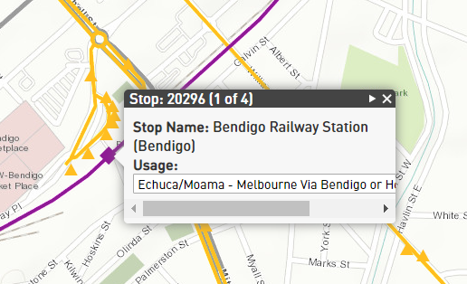

Staffing
Please outline measures being taken to manage crowds and loading at affected railway stations and level crossings, in the instance where additional staff and resources are required. This may include:
- Staffing – Authorised Officers, Customer Service staff
- Public Safety Officers (PSO’s)
- Policing
- Crowd management treatments e.g. water filled barriers, bollards, fencing or queuing systems
In the instance where there is an existing Traffic Management Plan which outline’s crowd management treatments, barriers etc, please indicate whether this document is attached.
Communications
Please outline any arrangements for additional Station P.A. announcements and content, including frequency and any signage required.
For Example:
- Due to the service changes for Yarra Trams through the Melbourne Park Precinct, MTM has agreed to open Gate C at Richmond Station, to ensure passengers can alight and trams at Stop 7D Olympic Blvd, and travel via Train between Richmond and Flinders Street. Announcements will be made on all platforms to ensure passengers are informed of the service changes.

- Due to the bus shuttle arrangements for the Ballarat Festival, passengers alighting at Ballarat Station will be directed to access the shuttles via Coffee Palace Lane, with the assistance of VLine staff and announcements upon arrival.

Information regarding the service changes and/or additional services will also be advertised via the Metro Trains Melbourne, VLine and Public Transport Victoria (DoT) website.

Victorian Train Network Map
https://www.ptv.vic.gov.au/assets/PDFs/Maps/Network-maps/91ec3c5794/PTVH5027_Network_Victorian_Train_Map_A4L_Digital_v1_FA.pdf
- Tram Service Changes

Service Changes
Please indicate how Tram services will be impacted and managed as a result of the event, including the nominated bus replacement and diversion details, as increased congestion may also affect the public transport network. This includes the Night Network.

Details of the service changes can be included as per below, or in table format. For example:

Sunday 16 August
Due to the road closures on Sydney Road between Blyth Street and Brunswick Road, the following tram service changes will apply from first service until 20:00:

- Route 19 North Coburg – Flinders Street will terminate at Stop 28 Moreland Road/ Sydney Road. A bus replacement will operate from a temporary bus stop and via Cameron Street, Moreland Road, Sydney Road, to Stop 27 Brunswick Depot and pick up passengers. Buses will then travel via Blyth Street, Lygon Street, Brunswick Road, Sydney Road to Stop 19 Brunswick Road/ Park Street.

- Route 19 Flinders Street – North Coburg will terminate at Stop 19 Brunswick Road/ Park Street. A bus replacement will operate with passengers via Park Street, Stranger Street, Brunswick Road, Lygon Street, Blyth Street, Sydney Road, to Stop 27 Brunswick Depot. Buses will return via Moreland Road, Peveril Street to Cameron Street.

Tram Stops between Stop 28 and Stop 19 will not be serviced from first service until 20:00.

Route No | Route Description | Block & Hold | Bus Replacement Route | Tram Diversion Route | Date | Time
1 | East Coburg – South Melbourne Beach
3 | Melbourne University - East Malvern (weekdays)
3a | Melbourne University – East Malvern (weekends)
5 | Malvern – Melbourne University
6 | Moreland - Glen Iris
11 | West Preston – Victoria Harbour Docklands
12 | Victoria Gardens – St Kilda (Fitzroy St)
16 | Kew – Melbourne University
19 | North Coburg – Flinders Street Station
30 | St Vincent’s Plaza – Etihad Stadium Docklands
35 | City Circle
48 | North Balwyn – Victoria Harbour Docklands | At Spenser & Collins Street |  |  | Sun 16 August | 12:00 to 12:15
Yarra Trams, Traffic Management and Victoria Police members will be on site to assist with block & hold movement of trams.
57 | West Maribyrnong – Flinders Street Station
58 | West Coburg - Toorak
59 | Airport West – Flinders Street Station
64 | East Brighton – Melbourne University
67 | Carnegie – Melbourne University
70 | Wattle Park – Docklands |  | N/A |  | Sun 16 August | 07:00 to 00:00
Due to the road closures on Batman Avenue, Route 70 tram services will terminate at Stop 6 Russell St/ Flinders St and Stop 7 Exhibition St/ Flinders St, and then Stop 7D Olympic Blvd. Passengers are advised to travel via Train between Richmond & Flinders Street Stations to and from the City.
72 | Camberwell – Melbourne University
75 | Vermont South – Docklands
78 | North Richmond - Balaclava
82 | Moonee Pond - Footscray
86 | Waterfront City Docklands – Bundoora RMIT |  |  | Divert at Victoria St via La Trobe and Spencer Sts | Sun 16 August | 07:00 to 00:00
96 | St Kilda Beach – East Brunswick |  |  | Divert at Victoria St via La Trobe and Spencer Sts | Sun 16 August | 07:00 to 00:00
Due to the road closures on Bourke Street, trams services will divert and will not service tram stop’s between Stop 01 Spenser Street and Stop 10 Albert Street.
109 | Port Melbourne – Box Hill

Summary of Additional Services
Some large events may require additional tram services. Additional tram services are only provided under agreement with DoT and Yarra Trams. If your event has been approved by DoT as requiring additional tram services, please include the service details below as provided by Yarra Trams.

Route |  | Details
86 | Waterfront City Docklands – Bundoora RMIT | Between 11:00 and 17:00, additional services will operate between Stop 01 Spencer St/ Bourke St & Stop and Stop 11 Melbourne Museum/ Nicholson St to an 8-minute frequency.

Tram Route and Stop Information
Please include details of the affected tram route including their Stop ID’s, which can be identified in SEMS using the Map and Information tools. Tram Routes can be identified in SEMS by the Green Lines, and Tram Stops by the Green Squares.
Using the information tool provided, you can select a Line or Square to identify their description, and then List affected tram stops.
Tram Route and Stop
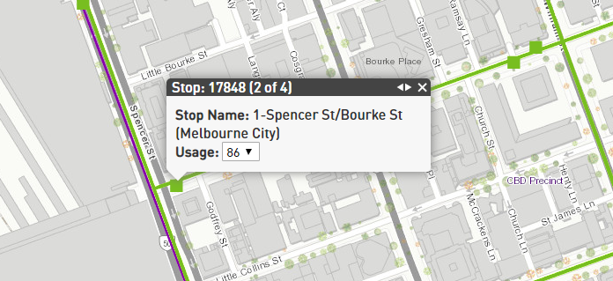

Staffing
The number, role and location of Yarra Trams staff for the event will be advised by Yarra Trams. Please include any agreed plans from Yarra on any alterations to staffing for your event.

Communications
Please outline any arrangements for additional platform or tram P.A. announcements and content, including frequency and any signage required.
For example:
Due to the service changes for Yarra Trams through the Melbourne Park Precinct, (MTM has agreed to open Gate C at Richmond Station) passengers can alight at Stop 7d Olympic Blvd, and travel via Train between Richmond and Flinders Street. Announcements will be made on trams to ensure passengers are informed of the service changes.

Information regarding the service changes and/or additional services will also be advertised via the Yarra Trams and Public Transport Victoria (DoT) website.
Cleaning
Please include details on additional cleaning operations or agreements to carry out cleaning of tram tracks post event.

Metropolitan Tram Network Map
https://www.ptv.vic.gov.au/assets/PDFs/Maps/Network-maps/417bb4810a/PTV_Tram-Network-Map_2017.pdf

Metropolitan Night Tram Network Map
https://www.ptv.vic.gov.au/assets/PDFs/Maps/Night-Network-maps/f1a3674c2c/PTV_Night-Tram_-network-map_2016.pdf

- Working Around Train and Tram Overhead Wires
Work Safe Compliance
Permit to Work: not required permit included

For any elevated equipment of any kind you must consider the envelope in which the equipment can be operated in all directions. Any equipment used must maintain a 3-metre clearance below and laterally from the overhead wire and never be above the overhead wire.
It is the responsibility of the person operating equipment in the vicinity of electrical assets to comply with these guidelines and contact the operator of the assets to obtain permits to work in the vicinity of the asset.

Metro Trains
https://www.metrotrains.com.au/metrositeaccess/

VLine
https://corporate.vline.com.au/Network-Access/Network-Access

Yarra Trams
https://yarratrams.com.au/permits-for-works

When does a ‘Permit to Work’ from either the electrical distribution or traction (tram or train) company need to be obtained?

A ‘Permit to Work’ may be provided to you by either the traction or electrical distribution company when work is to be undertaken within three (3) metres of any overhead electrical asset. The Permit will generally outline all the safety precautions taken by the company to assist you in your work. The Permit will also stipulate any requirements (Special Provisions) that may have to be implemented to assist in the safe completion of your work near the electrical lines.
Where work is to be undertaken between 3 and 6.4 metres from the electrical line and a safety concern is evident, the electrical or tram company should be contacted for assistance.
Following an inspection and possible negotiations, the issue of a ‘Permit to Work’ may be considered appropriate to assist in declaring required safety clearances and safety related matters and any precautions taken.

- Bus & Coach Service Changes

Service Changes
Please indicate how Metropolitan and Regional Bus and Coach services will be impacted and managed as a result of the event, including the nominated block & hold, bus replacement and/ or diversion details, as increased congestion may also affect the public transport network. Please include details of any bus stop closures, temporary bus stops or additional bus shuttle arrangements. This includes Night Network Services.

Details of the service changes can be included as per the below description, or in table format.
For example:

Description:
Sunday 16 August
From 6:00 until 20:00, Bus Routes 11 and 12 in Ballarat will be impacted by the Ballarat Cycling Race on Sturt Street, between Doveton and Lydiard Streets. Eastbound Services will be diverted and travel via Mair Street. Westbound Services will be diverted and travel via Dana Street.
The following bus stops will not be serviced on Sunday 16 August, and require a Customer Bulletin and Bag:
- Central Square SC/Sturt St (Ballarat Central) ID 35118
- Armstrong St/Sturt St (Ballarat Central) ID 35034
The following temporary bus stops will be required on Sunday 16 August:
Street Address | Cross Street | Date
(Approx. 301) Dana St | Armstrong St South (South Side) | 16 August
(Approx. 501) Dana St | Dawson St South (South Side) | 16 August
(Approx. 614) Mair St | Raglan St North (North Side) | 16 August
(Approx. 402) Mair St | Doveton St North (North Side) | 16 August

Table:

Route No. | Route Description | Road Closure | Diversion Route | Diversion Time | Stop Closures
11 | Ballarat Station – Wendouree Station via Howitt St | Sturt Street between Doveton and Lydiard Streets | Eastbound via Mair Street  Westbound via Dana Street | 6:00 to 20:00 | - Central Square SC/Sturt St (Ballarat Central) ID 35118  - Armstrong St/Sturt St (Ballarat Central) ID 35034
12 | Ballarat Station – Wendouree Station via Forest St

Temporary Bus Stops Required
Street Address | Cross Street | Date
(Approx. 301) Dana St | Armstrong St South (South Side) | 16 August
(Approx. 501) Dana St | Dawson St South (South Side) | 16 August
(Approx. 614) Mair St | Raglan St North (North Side) | 16 August
(Approx. 402) Mair St | Doveton St North (North Side) | 16 August

Summary of Additional Services
Some large events may require additional bus services, due to their location and event requirements. Please include any details regarding the additional services and stops required, particularly in the instance where services operate along an existing public route.
Additional bus services for events must be paid for by event organisers, as part of the overall event costs. The DoT does not have any funding for this purpose. In the instance where event organisers require advice or assistance with additional bus planning, DoT can provide this where possible. Please contact our Special Events team for further advice at event.notification@ptv.vic.gov.au

Bus Route and Stop Information
Please include details of the affected bus stops including their Stop ID’s, which can be identified in SEMS using the Map and Information tools. Metropolitan and Regional Bus Routes can be identified in SEMS by the Orange Lines, and Bus Stops by the Orange Triangles. Regional Coach Routes can be identified in SEMS by Light Purple Lines, and Coach Stops by the Light Purple Hectogons.
Using the information tool provided, you can select a Line or Triangle to identify their description, and then List affected bus stops and any replacement temporary bus stop locations.
Describe arrangements in place for any additional staff to manage the temporary bus stops.
Bus Route and Stop Coach Route and Stop
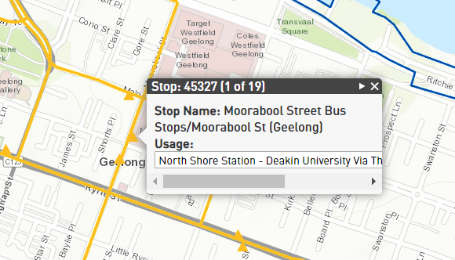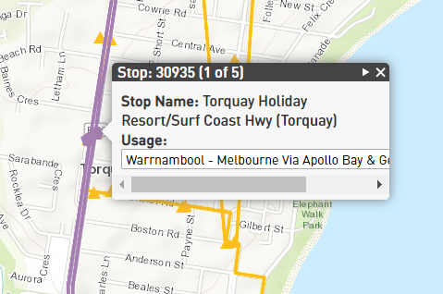

Staffing
Please include any arrangement for additional staffing to assist with operations during your event.
In the instance where there is an existing Traffic Management Plan which outline’s crowd management treatments, barriers, staff etc, please indicate whether this document is attached.

Communications
Customer Bulletins are required for each affected bus stop when services cannot access a specific bus stop. Customer Bulletins assist customers with information regarding the details of when the stop will close and reopen, and where their nearest bus stop is to access services. Confirmation of bus stops that require a Customer Bulletin are required, and whether the stop is also required to be closed or ‘bagged’ if the closure will occur all day.
If a bus stop requires bagging, the DoT carries this out via an external contractor prior to and post event and may require access to road closures to carry this out. Alternatively, an arrangement for the event organiser or local bus operator to post the customer bulletins can be formed, once copies of the customer bulletin are drafted by DoT and sent to the relevant stakeholder.

Example of a DoT Customer Bulletin:

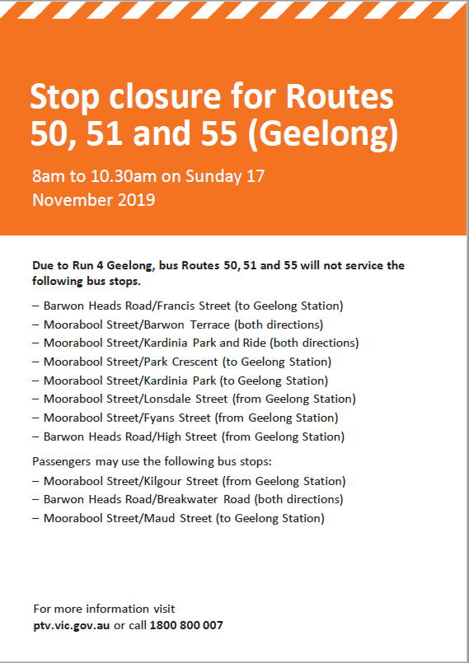

Information regarding the service changes will also be advertised via the public transport operator and Public Transport Victoria (DoT) website.

Metropolitan Local Area Maps
https://www.ptv.vic.gov.au/more/maps/metropolitan-local-area-maps/

Metropolitan Bus Night Network Map
https://www.ptv.vic.gov.au/assets/PDFs/Maps/Night-Network-maps/e8f84509e5/PTV_NightBus_map_2016.pdf

Regional Coach Night Network Map
https://www.ptv.vic.gov.au/assets/PDFs/Maps/Night-Network-maps/d8539d780b/PTV_NightCoach_map_2016.pdf

- Event Day Communications

Please include the following details;

- Location of Event Operations Centre (EOC)
- Operating hours of EOC
- Contact numbers for Event Day staff
- Contact names and numbers for public transport staff managing services on event day

